How to Assign a Program Officer to Your EEGMaster Account
- Click on your account profile in the upper right of the header and then select “My account”
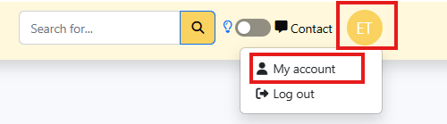

- Select your Program Office from the drop-down menu and click save.
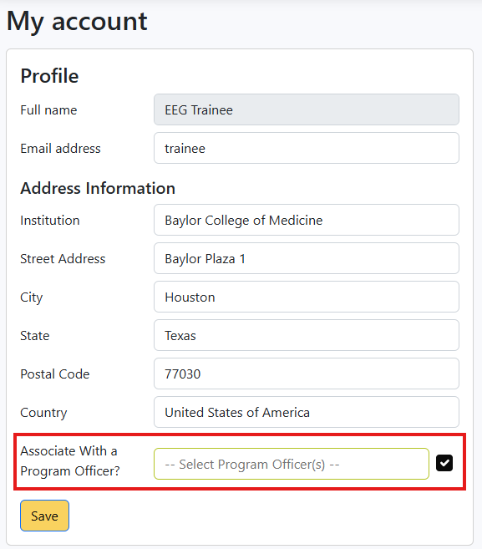

- Your selected Program Officer will receive an email invitation and can confirm your affiliation. Once confirmed, you’ll gain access to all resources available through a Program Officer–level association.

